UCISA PCMG Toolkit

Effective Benefits Management for IT and Business Change Projects

Simon Geller, University of Sheffield
May 2016

Contents

Introduction | 2
Definitions | 2
Benefits Management Maturity | 3
Roles and responsibilities | 4
Identifying Project Benefits | 6
Key concepts | 7
Creating and maintaining the Project Benefit Register | 9
Analysing and evaluating Benefit | 11
Benefit Management and Review | 11
Budgeting for Benefit Management | 12
Benefit Management Checklist | 13
Final thoughts | 14
Appendix 1 | 15
Appendix 2 | 15
Appendix 3 | 15
Acknowledgements | 16

- Introduction
Welcome to the UCISA PCMG Benefits Management Toolkit. This is part of a series of Toolkits being rolled out by PCMG. We aim to provide an overview of the principles behind Benefits Realisation and some basic tools for you to use in your projects in HE and other sectors, while providing some signposts to more sophisticated techniques that are available should your project require them.
- Definitions

What is a Benefit?
“A benefit is a positive and measurable impact of change” APM BoK
Also defined by Gerald Bradley as “an outcome of a change which is perceived as positive by a stakeholder”. This differs as it states perception rather than measurable, perhaps because not everything can be easily measured. In an HE environment it is frequently necessary to think out of the box when identifying project benefits, since simple measures of profit and loss do not apply.

What is Project Benefits Management?
Benefits management aims to ensure that benefits that have been identified at the start of a project are realised and that any benefits that emerge as the project progresses are properly exploited. As many project benefits are not realised until after the project is closed it is important that appropriate structures are put in place to monitor benefits realisation post project.

What is a Benefits Log?
The Benefits Log seeks to identify the benefits that are to be achieved at the start of a project, assign them an owner, identify means by which the benefit can be measured and manage changes to the benefits that can be realised as the project progresses.

What is a Benefits Owner?
A Benefit Owner takes responsibility for a benefit or set of benefits associated with a project. They ensure that the benefits and the measures put in place to ensure that they are achieved are realistic and that these benefits continue to be realised post project.

- Benefits Management Maturity
The benefits of Project Benefits Management are maximised where there is a mature approach to managing Benefits across the institution. In the last few years we have started to see signs of this maturity in many of our own institutions. The overall environment, however, remains patchy and even organisations with a mature approach to managing projects have not necessarily updated their approach to Project Benefits Management. In developing your approach to Project Benefits Management, aim to achieve as many as possible of the following signs of Project Benefits Management maturity:
- Project governance bodies and senior management engage with and promote effective Project Benefits Management – and accept the time and resource implications
- The key role of effective Benefits Management in projects is understood and accepted by all staff engaged in Project and Change management activities
- Effective Benefits Management is fully embedded in institutional Project Management processes
- There is a clear and structured approach to Benefits Management that is adopted for all IT and Business Change Projects
- Project and Service Benefits Management are aligned with wider University policy - with key IT Projects and Services often featuring on the current institutional Benefits Register
- As Projects progress the Benefits begin to be realised and stakeholders are more satisfied with project outcomes

- Roles and responsibilities
Effective Benefits Management requires that:
- Project Benefits and impacts are defined in business terms that are readily understandable to stakeholders
- Project Benefits are identified and recorded in a Benefits Log by the Project Board and Team
- Reliable and up to date information is maintained on Project Benefits throughout the lifetime of the Project. The Project Manager is not responsible for the delivery of benefits but he is responsible for ensuring that benefits realisation procedures are put in place by the Project Team
- Project Sponsors, Benefits Owners and other Project stakeholders are engaged with Risk Management and accept the time and resource implications of required Benefits Management processes
- There are appropriate reporting processes to ensure that Project governance bodies can monitor Benefits realisation status – ensuring the benefits remain clear and still achievable in despite any problems/changes/risks/issues which occur during the project.
- Project decision making processes are fully informed by identification of the Project Benefits
A well managed approach to Benefits will greatly improve the ability of the Project to succeed. Clearly stated project objectives, i.e. the benefits which will be realised, enable the sponsor, project manager, project board and stakeholders to ensure the project will proceed as planned or deviation from the plan and/or business case are effectively managed.

4.1 Responsibilities of the Project Manager
The Project Manager has key responsibilities with regard to Benefit.

The Project Manager, in conjunction with the Project Team, is responsible for ensuring that all Benefits are identified, are regularly reviewed and have an Owner. The Project Manager must ensure that the project completes and thus benefits should be realised.

4.2 Responsibilities of the Project Sponsor and Project Board
The sponsor and stakeholders take overall responsibility for the project benefits.

4.3 Responsibilities of the Benefit Owner
Each Benefit must have a Benefit Owner who has responsibility for monitoring and measuring the Benefit. The Benefit Owner has ultimate responsibility for monitoring each Benefit that they own. The task of monitoring the Benefit may be delegated but responsibility stays with the owner.

The Benefit Owner will have the responsibility of monitoring each Benefit assigned to them, however, overall responsibility for the Benefit Management process lies with the Project Sponsor.

4.4 Responsibilities of the Service Portfolio Manager
As the project reaches completion, the deliverables of the project become part of the portfolio of services that the institution offers. Under the ITIL methodology, the Service Portfolio Manager “ensures that the service portfolio as a whole supports the achieving of business goals by IT Service Consumers in economic manner (business value)” Thus the Service Portfolio Manager should monitor the work of the Benefits Realisation Team and adjust the service to ensure that the project outputs are optimised.

5. Identifying Project Benefits
The first step in Benefit Management is Benefit identification. This should take place at the mandate stage before the business case is complete.

On a smaller project this could be led by the Project Manager and supported by the Project Sponsor and other key stakeholders. On a larger project it would be better to organise facilitation.

It is a good idea to run this as a workshop so that all are involved in the discussion about Benefits and what should be done to maximise them. Normally when we initiate a Project some of the Benefits associated with it are obvious.
- In your Benefits identification session, leave nothing out
- Consider previous projects
- Review Project assumptions
- Look for hidden Benefits
- Refer to your institutional objectives

6. Key Concepts

Enablers

Changes

Benefits

Aims

Step 1: Aims
Any attempt to identify Benefits should start with an exercise to identify the aims of the project, i.e.:
- What is the project trying to achieve? – Why are we doing the project?
E.g. To improve…, To reduce…, To increase…, To … more effectively etc.
- The project should support the institution’s objectives
Aims set the boundary for the project scope and summarise the main purpose of the project
The project aims form the starting point for Benefits Realisation Management – once we know the purpose of the project and what it is trying to deliver, we can then look at how these aims can be achieved by the delivery of appropriate benefits.

Step 2: Benefits
The next exercise is to identify the benefits that must be delivered to achieve the aims identified in Step 1, e.g.: Improved…, Reduced…, Increased…
These will range from operational benefits (e.g. increased efficiency and effectiveness) through to more strategic benefits (e.g. raised profile of research staff).

Step 3: Enablers
Once the project aims and benefits have been identified, the next exercise is to identify the project enablers.
An enabler could be a tool (e.g. IT system), a policy (e.g. information management policy), a building (e.g. Information Commons), etc.
Note: The enablers don’t usually by themselves deliver benefits – benefits must be actively realised via organisational change.

Step 4: Changes
This exercise should identify the organisational changes that must occur in order for the benefits identified in Step 2 to be realised – for example changes to working practice/culture and achieving user buy-in.

Once the above information has been gathered, a Benefits Map can be developed.

Benefits Map
The Benefits Map provides a visual overview of the information identified during the Benefits Workshop – i.e. the project aims, benefits, enablers and changes. The general form of the Benefits Map is as follows:

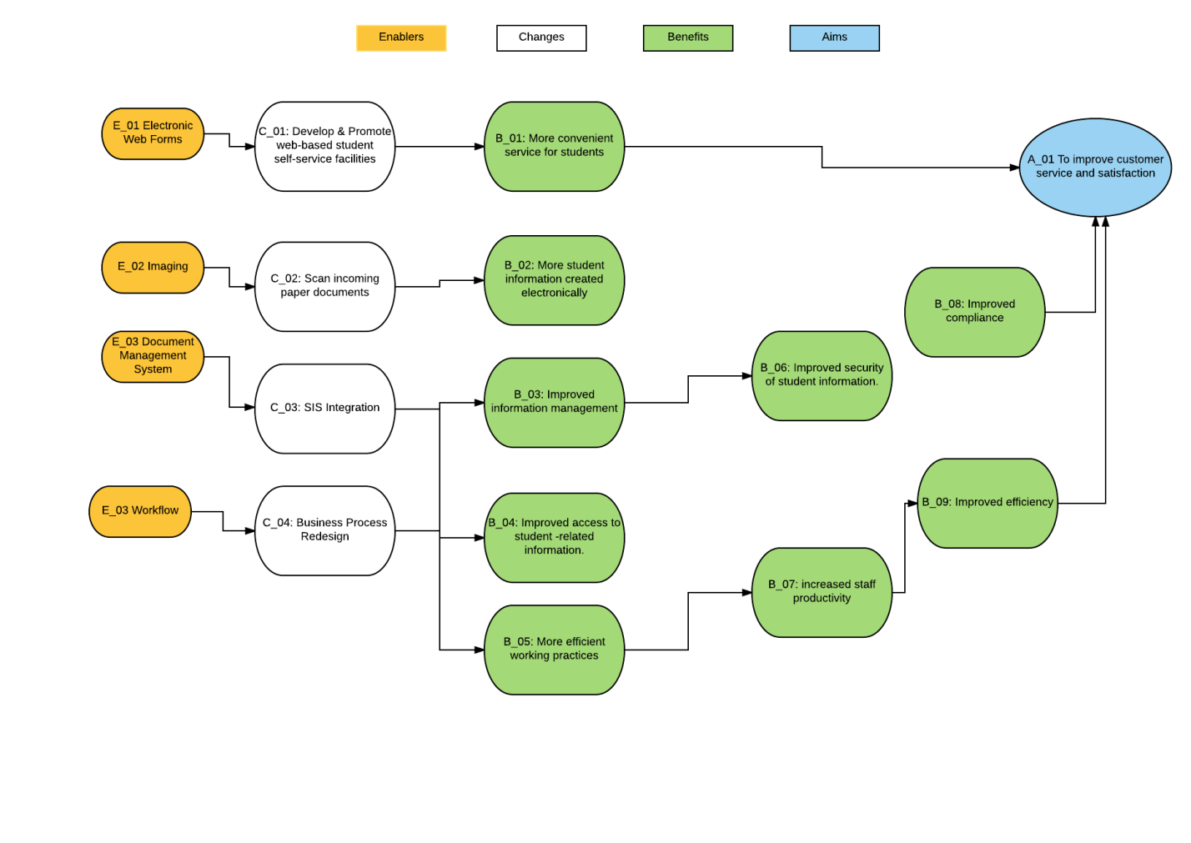
Mind mapping tools, Visio or LucidChart can be used to create Benefits Maps.

7. Creating and maintaining the Project Benefit Register
The Benefit Register is normally initially filled in for the first time during Project start-up following the Benefit identification session with the Project Sponsor and key stakeholders.
The most common entries in the Benefit Log include:
- Reference Number – needed when referring to Benefits in other Project documentation
- Description – a short description of the Benefit
- Owner – this is the person or entity that has been given the authority to manage a particular Benefit and is accountable for doing so
- Measures – How will we measure the extent to which the benefits are being realised? This can be more opaque in an educational institution where benefits cannot necessarily be linked directly to financial gain
- Benefit Owner – this is the person or entity that has been given the authority to manage a particular Benefit and is accountable for doing so
- Date of Last Review – this is the date the Benefit was last reviewed by the Benefit Owner
- Project Board Decision – a description of the action or comment from the Project Board to the Benefit

A simpler Benefits Register would take the form of the table below. However, beware of having solely templated Benefits.
Benefit | Owner | Measures | Notes

The NHS Institute for Innovation and Improvement, now defunct, proposed a more detailed benefits realisation plan:
Desired benefit | Stakeholders impacted | Enablers required to realise benefit | Outcomes displayed if benefit realized | Current baseline measure | Who is responsible | Target  date
See more at: http://www.institute.nhs.uk/quality_and_service_improvement_tools/quality_and_service_improvement_tools/benefits_realisation.html#sthash.umBKpRgA.dpuf

The University of Sheffield used a Benefits Dependency method to map out the dependencies between benefits that would accrue from improving its collaboration systems.

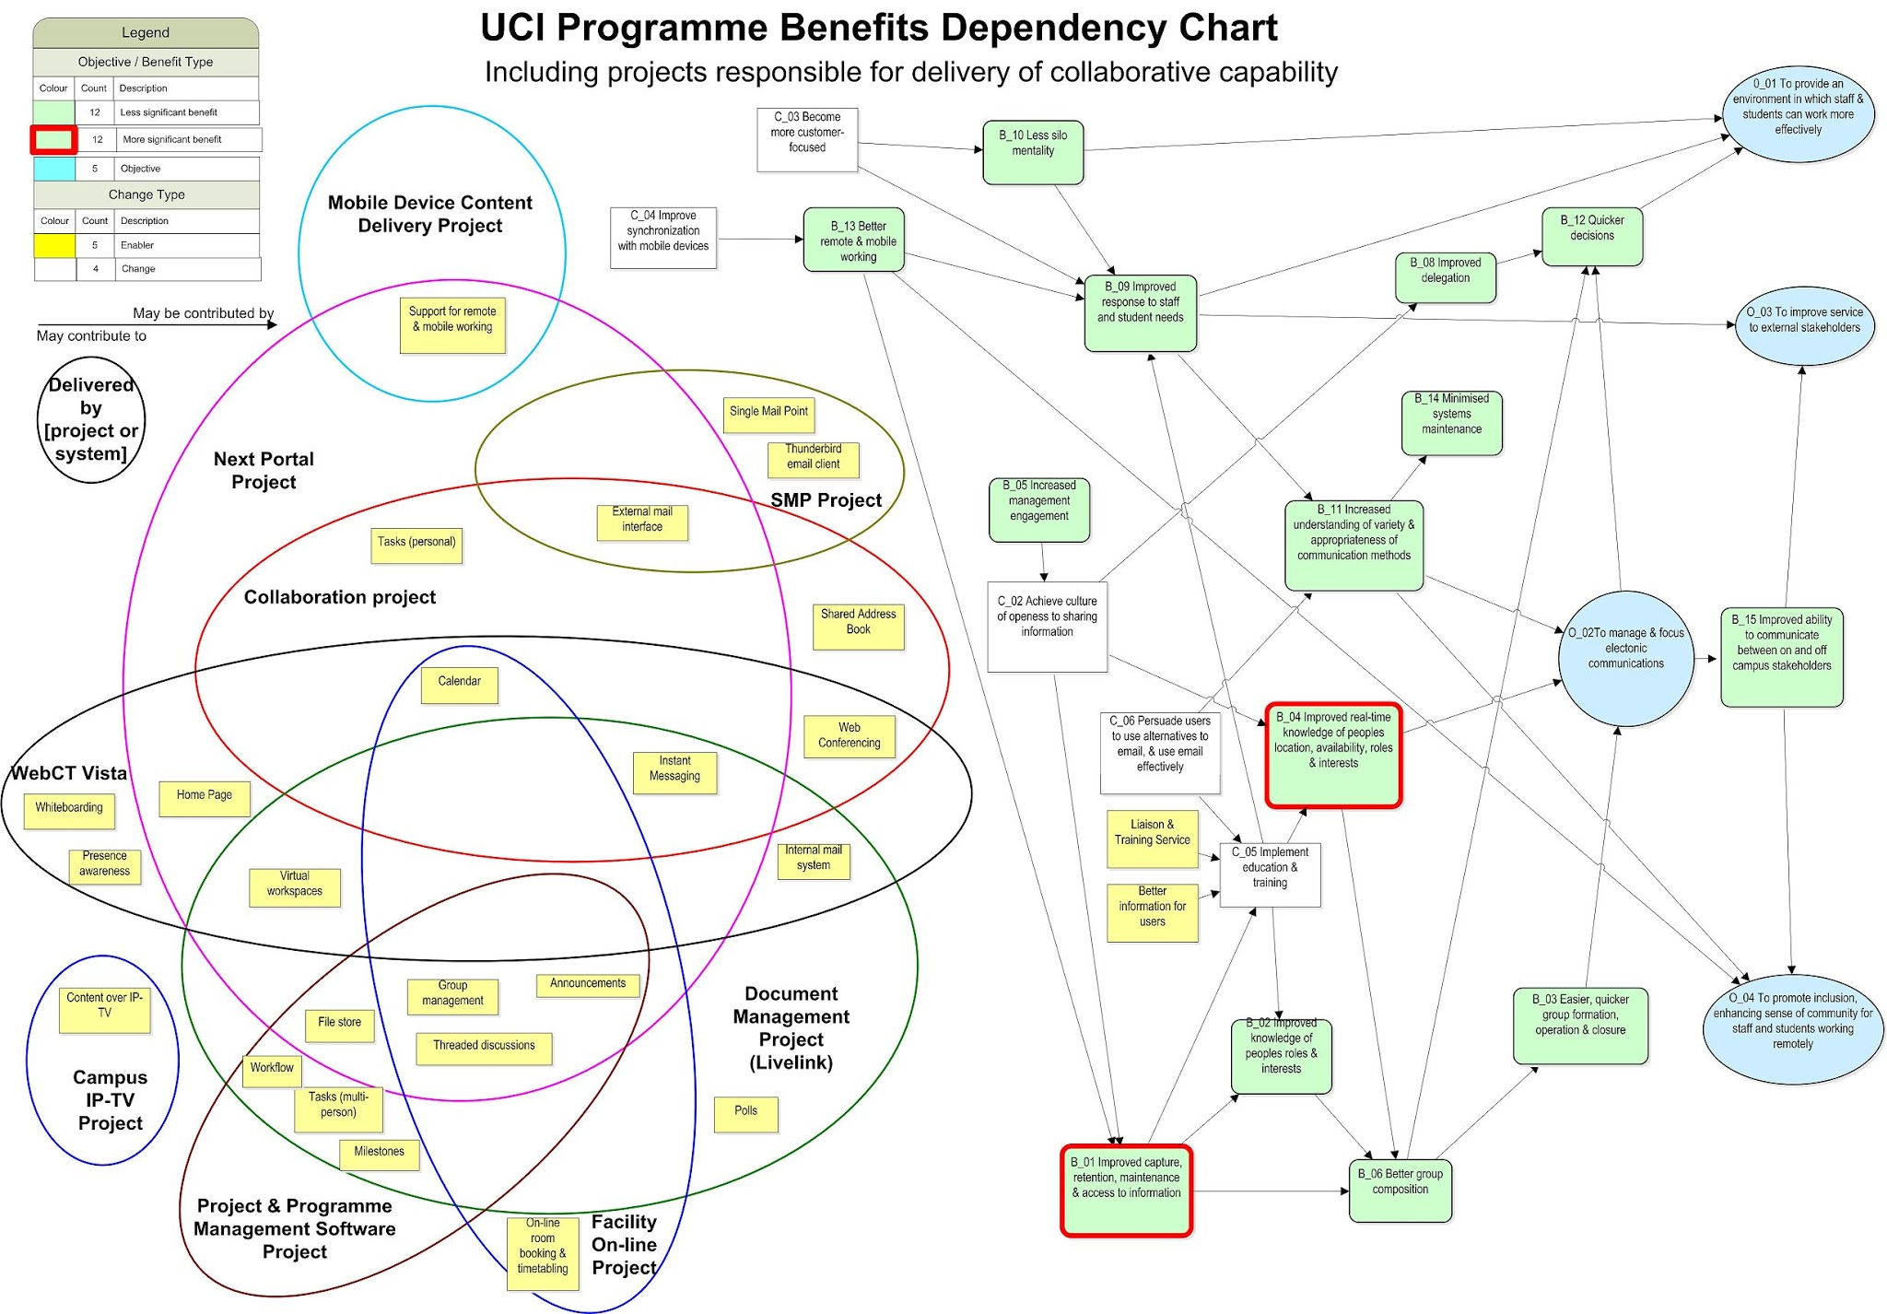

(View Original Here)

This was highly beneficial in that it identified benefits that were being realised across a range of projects to a common purpose. In the end many of these benefits were realised by the adoption of Google Apps for HE.
PRINCE2 identifies other Benefits that may be relevant for your Project. These include:
- Strategic/commercial
- Economic/financial/market/legal and regulatory organisational/management/human factors
- Environmental
- Political
- Technical/operational/infrastructure
These categories fit broadly under the PESTLE acronym – Political, Economic, Social, Technical, Legal and Environmental

8. Analysing and evaluating Benefit
Cost Benefit Analysis – CBS is the normal method of evaluating whether the benefits accrued by a project justify the expense of carrying it out. In the HE environment, costs and benefits can be somewhat opaque. Factors such as student satisfaction, future recruitment levels and the existence of an estate with a fixed cost need to be taken into account. A range of resources on CBA is available.
9. Benefit Management and Review

9.1 Benefit Management reporting – regular benefit review
Progress on Benefit Management must be reported to Project Boards or other Governance groups as part of the regular reporting cycle.
As the project nears closure a Benefits Management Team (BMT) should be set up – for a smaller project this may be an individual. The remit of the team is to review benefits and ensure that they continue to be maintained post project. The team should consist of the benefits owners identified during the course of the project.

9.2 Project closure
Most benefits will normally be realised in an operational environment – therefore, potentially long after the project itself has finished. It will be important when considering all of the steps taken to develop the opportunity to realise the overall project benefits to consider the impact on cost, along with the identification of whether and to whom ownership may need to be transferred.

10. Budgeting for Benefit Management
The management of benefits realisation should be central to any programme or project. Initial activities should take place during the planning phase, and will continue both throughout and possibly beyond the project life cycle, depending on exact requirements. Throughout, benefits and the baseline/target value should feed into the project Business Case, and be used to help in determining whether the project should be started, continue, or run for its duration.
For each benefit identified, more detailed work should take place in order to further assess:
- The value of each benefit
- When each may be achieved
- Organisational impact and priority
- Any dependencies
- Costs required to manage the realisation of the benefit
- Risks associated with the (dis) benefit
- Whether and how the benefits may interrelate

These assessments should feed into the project’s Business Case – providing evidence to support whether and what level of return on investment can be expected, and ultimately whether or not the project should continue.

11. Benefit Management Checklist
The following checklist can be used by the Project Manager and other stakeholders to review whether effective Benefit Management is in place for a Project:
Item | In place (Yes/No)
1. Are overall roles and responsibilities with respect to Benefits defined and understood by the Project Manager, Project Sponsor and Project Board (or other governance group)?
2. Are the roles and responsibilities associated with Benefit Ownership defined and understood by Benefit Owners?
3. Is the Benefit Log complete and credible taking into account the current status of the Project?
4. Is each individual Benefit clearly owned by an empowered individual who has the authority in practice to progress the actions required to manage the Benefit?
10. Is there clear evidence that all Benefits are being regularly reviewed by the Project Manager, Project Sponsor and Benefits Owners?
11. Are there hidden Benefits that may be referred to in other Project documentation or communications between Project stakeholders which have not yet been moved into the Benefit Management framework?
12. At the end of the Project are all Benefits handed over and who to?

12. Final thoughts
Delivering benefits to the business is ultimately what projects are all about. Too often we focus on the product that the project is due to deliver, rather than the benefits the product is supposed to deliver. Rigorous examination of the benefits may well mean that projects never reach the mandate stage, as the benefits that the proposer has envisaged simply aren’t there, or may substantially alter the course of the project as the benefits change or it becomes apparent that the course of the project is altering in a way that will not deliver on benefits.

Once a project is completed, the work of the Benefits Realisation team really starts. Delivering a product that is not used by the organisation has no benefit. The Project Sponsor and the key stakeholders must work together to ensure that the benefits of the project are realised for the lifetime of the products that the project delivered.

Appendix 1 – Aligning Project Benefits with institutional objectives
It helps to achieve senior management buy-in if Benefit Management for IT Projects and services is aligned to the wider institutional policy. Look in your organisation’s strategy for documents relating to the overall benefits the institution hopes to accrue from its activities.
Appendix 2 – Benefits Case Studies
PCMG is collecting Case Studies from institutions who have successfully implemented Benefits Realisation strategies, either on individual projects or institution wide. To view these go to
http://www.ucisa.ac.uk/groups/pcmg/resources.aspx
Appendix 3 – Benefits in an Agile environment
Benefit management in an Agile Project is fundamentally the same as in a conventional Waterfall approach. However, Agile practitioners claim that using an Agile approach increases many Benefits and in particular, by rolling out products early, Benefits can be realised earlier and start to be realised as the project progresses. For this reason, it is even more important that Benefits are clearly identified at the mandate stage, before the business case is complete. Equally, Benefits should be monitored through the course of the project because, as the deployed solution will change during the course of the project, Benefits will change as well. The Agile approach recognises that change is inevitable, so “allows for change and harnesses its benefits... change is actively encouraged in order to evolve the most appropriate solution.”

Acknowledgements
Thanks to the following for their valuable contributions:
Tim Snow, University of Sheffield (Benefits Mapping)
Simon Hogg, Oxford Brookes University
Nick Dods, University of Liverpool

Roles of IT Service Management according to ITIL® 2011 https://www.itsmprocesses.com/Wiki/Englisch/ITIL%20Roles.htm
DSDM Agile Project Management Handbook v1.2

