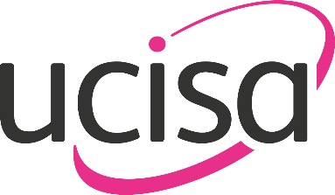
UCISA24 Leadership Conference and Exhibition 13th to 14th March 2024

Risk Assessment for Simple Exhibition Stands

Stand Name: | Stand Number:

Risk:
Who could be harmed:
Control measures in place:

To the best of my knowledge the information provided is correct. The control measures in place control risk to an acceptable degree.

Signed: | Name: | Date:

Please note:
This is a very basic risk assessment format for simple risks only. Multiple or complex risks will require a more detailed risk assessment.

